School Site Selection Using Spatial Analysis
Project: Spatial Data Analysis - Homework 1
Authors: Ameer Saleh & Bara Mhana
Date: December 1, 2025
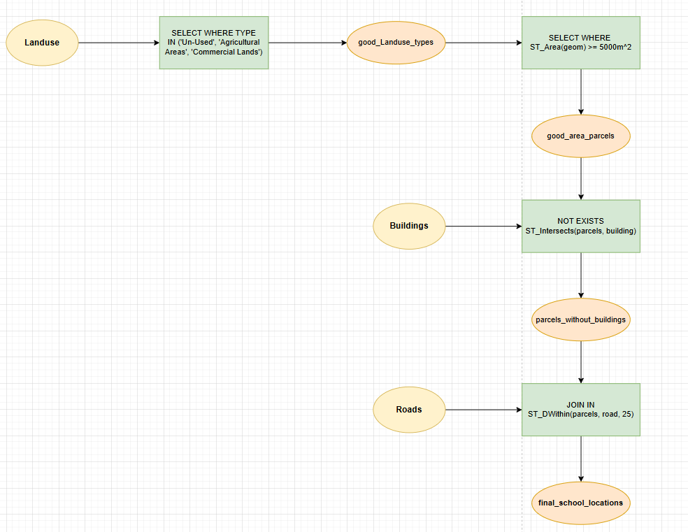

Executive Summary
This project identifies suitable locations for new school construction using PostGIS spatial analysis and QGIS visualization. From 140 initial land parcels, 7 suitable sites were identified totaling 52,779.20 m² through systematic application of four selection criteria.
Key Results:
- 7 suitable parcels identified (5% success rate)
- Average parcel size: 7,539.89 m²
- 85.7% of sites directly adjacent to roads
- Mix of un-used (71.4%) and agricultural lands (28.6%)

1. Introduction

1.1 Objectives
Identify suitable land parcels for school construction using multi-criteria spatial analysis in PostGIS with the following requirements:
- Land use types: Un-Used, Agricultural, or Commercial
- Minimum area: 5,000 m²
- No existing buildings on parcels
- Within 25m of nearest road

1.2 Tools and Technologies
- PostgreSQL + PostGIS - Spatial database and analysis
- QGIS 3.16+ - Geographic visualization
- SQL - Query development

2. Data and Study Area

2.1 Database Schema
Landuse Table (Primary dataset)
- idd - Primary key
- type - Land use classification
- area - Parcel area (m²)
- geom - Polygon geometry
Buildings Table
- idd - Primary key
- geom - Building footprints
Roads Table
- idd - Primary key
- name - Road name
- geom - Road centerlines

3. Methodology

3.1 Analysis Workflow
Initial Landuse (140 parcels)
↓
① Land Use Type Filter → 140 parcels
↓
② Area ≥ 5000 m² → 23 parcels
↓
③ No Buildings → 17 parcels
↓
④ Road Proximity ≤ 25m → 7 parcels (FINAL)

3.2 Sequential Filtering Approach
Each criterion progressively narrows the candidate set, ensuring all requirements are met while optimizing query performance.

4. Selection Criteria

Criterion 1: Land Use Type
Requirement: Un-Used, Agricultural Areas, or Commercial Lands
WHERE type IN ('Un-Used', 'Agricultural Areas', 'Commercial Lands')
Result: 140 parcels retained

Criterion 2: Minimum Area
Requirement: Area ≥ 5,000 m²
AND ST_Area(geom) >= 5000
Result: 23 parcels (83.6% eliminated)

Criterion 3: No Buildings
Requirement: No building footprints intersecting parcels
AND NOT EXISTS (
SELECT 1 FROM buildings b
WHERE ST_Intersects(l.geom, b.geom)
)
Result: 17 parcels (26.1% eliminated)

Criterion 4: Road Proximity
Requirement: Within 25m of nearest road
AND EXISTS (
SELECT 1 FROM roads r
WHERE ST_DWithin(l.geom, r.geom, 25)
)
Result: 7 parcels (58.8% eliminated)

5. Technical Implementation

5.1 Complete SQL Query
-- Final query applying all criteria
CREATE TABLE final_school_locations AS
SELECT
l.idd,
l.type,
l.owner,
l.area,
l.geom,
ST_Area(l.geom) as calculated_area,
(SELECT MIN(ST_Distance(l.geom, r.geom))
FROM roads r) as distance_to_nearest_road
FROM
landuse l
WHERE
-- Criterion 1: Land use type
l.type IN ('Un-Used', 'Agricultural Areas', 'Commercial Lands')

-- Criterion 2: Minimum area
AND ST_Area(l.geom) >= 5000

-- Criterion 3: No buildings
AND NOT EXISTS (
SELECT 1
FROM buildings b
WHERE ST_Intersects(l.geom, b.geom)
)

-- Criterion 4: Road proximity
AND EXISTS (
SELECT 1
FROM roads r
WHERE ST_DWithin(l.geom, r.geom, 25)
)
ORDER BY
ST_Area(l.geom) DESC;

-- Add primary key and spatial index
ALTER TABLE final_school_locations ADD PRIMARY KEY (idd);
CREATE INDEX idx_final_sites_geom ON final_school_locations USING GIST(geom);

6. Results and Analysis

6.1 Filtering Progression
Step | View Name | Count | Criteria Applied
1 | suitable_landuse_types | 140 | TYPE IN (Un-Used, Agricultural, Commercial)
2 | suitable_area_parcels | 23 | ST_Area(geom) ≥ 5,000 m²
3 | parcels_without_buildings | 17 | NOT ST_Intersects with buildings
4 | final_school_locations | 7 | ST_DWithin roads 25m
Overall Reduction: 95.0% (140 → 7 parcels)

6.2 Final School Sites
ID | Land Use Type | Area (m²) | Distance to Road (m)
20 | Agricultural Areas | 9,935.86 | 0.00
131 | Un-Used | 8,247.02 | 0.00
215 | Un-Used | 7,981.13 | 0.00
8 | Un-Used | 7,283.46 | 0.00
145 | Un-Used | 7,214.55 | 0.00
11 | Un-Used | 6,255.88 | 14.22
17 | Agricultural Areas | 5,861.30 | 0.00

6.3 Summary Statistics
Area Analysis:
- Total Area: 52,779.20 m²
- Mean: 7,539.89 m²
- Minimum: 5,861.30 m²
- Maximum: 9,935.86 m²
Distance to Roads:
- Mean: 2.03 m
- Sites adjacent to roads: 6 (85.7%)
- Maximum distance: 14.22 m
Land Use Distribution:
Land Use Type | Count | Total Area (m²) | Percentage
Un-Used | 5 | 36,982.04 | 71.4%
Agricultural Areas | 2 | 15,797.16 | 28.6%
Total | 7 | 52,779.20 | 100%

7. QGIS Visualization

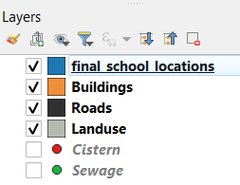
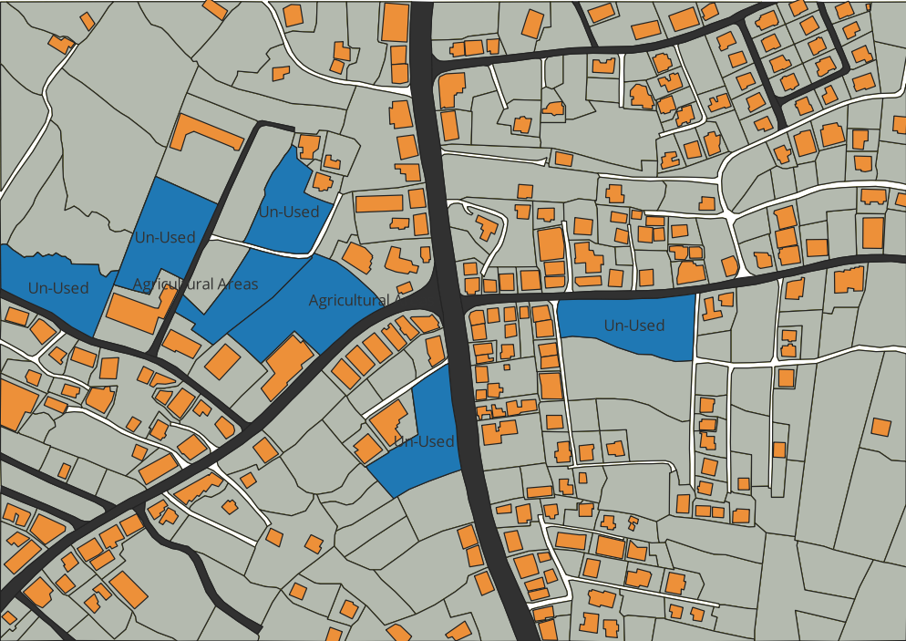

7.1 Loading Data in QGIS
Method 1: Direct PostGIS Connection
- Layer → Add Layer → Add PostGIS Layers
- Create connection to database
- Select final_school_locations table
- Add to map
Method 2: DB Manager
- Database → DB Manager → PostGIS
- SQL Window → Execute query
- Check "Load as new layer"

7.2 Map Styling
Final School Sites:
- Fill: Green (#4CAF50), 60% opacity
- Outline: Dark Green (#2E7D32), 1.5pt
- Labels: Site ID and area
Supporting Layers:
- Roads: Gray lines (1.5pt)
- Buildings: Red outlines (0.5pt)
- 25m Road Buffer: Blue dashed (40% opacity)

7.3 Map Layout Elements
- Title: "Suitable School Sites Analysis"
- Legend with all layers
- Scale bar and north arrow
- Data sources and projection info
- Results summary table

8. Conclusions and Recommendations

8.1 Summary
Successfully identified 7 suitable parcels totaling 52,779 m² through rigorous spatial analysis. All sites meet the four selection criteria and are development-ready with excellent road access.

8.2 Immediate Next Steps
- Site Verification - Field visits to all 7 sites
- Environmental Assessment - Phase I environmental studies
- Cost Analysis - Land appraisals and development estimates
- Stakeholder Engagement - Community consultation and owner contact

8.3 Future Enhancements
Additional Analysis:
- Multi-criteria decision analysis (MCDA) with weighted criteria
- Cost-benefit analysis integration
- Student population density mapping
- Environmental constraints (slopes, flood zones)
- Traffic and accessibility modeling
Data Improvements:
- Property values and ownership details
- Existing school locations and capacity
- Demographic and enrollment projections
- Utility infrastructure availability

Report prepared by: Ameer Saleh & Bara Mhana
Course: Spatial Data Analysis
Assignment: Homework 1 - Site Selection using PostGIS
Date: December 1, 2025
END OF REPORT

